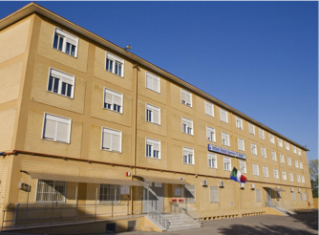
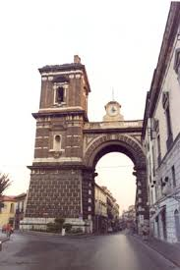AVERSA
Our school, ISISS “Enrico Mattei”, is situated in Aversa, a large and historical town in the north of Naples, in the south of Italy.
Its origin goes back to 1971/72, when it was born as a vocational high school with only one department: Commerce. Today it includes four departments: the vocational departments of Commerce and Social – Health care Services, and the technical departments of Graphics and Tourism.
It enrols 1275 students, aged between fourteen and eighteen, coming from Aversa and its surroundings (about 10 municipalities with 100,000 inhabitants) and from low social and cultural backgrounds.
The school operates in a territory characterized by a deep social and economic imbalance with a high unemployment especially among young people. Our school aims at giving students opportunities and motivation to get a job at the end of the five years of study. The school has been able to enhance its training offer through alternating training activities that engage students in real work experiences at local businesses and societies. Aware of its great task concerning the education and training of new generations, our school is determined to carry it out pursuing the values of equalities, trust, cooperation and solidarity.
In particular, the educational purposes that our school intends to pursue are the following ones:
- Help students to become more responsible and autonomous
- Help students to acquire tools to analyze the complexity of realty in order to be not influenced by it passively
- Help students to obtain a vocational training spendable on the work market.
About that, the school provides students with a number of laboratories: Music, theatre, Graphics, linguistics, informatics, and also a big and well-stocked library, as the pictures show:
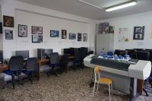
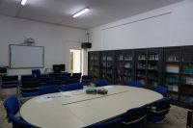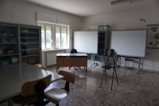
Apart from the educational programs, which are integral parts of its educational objectives, the school takes part in many extra-curricular projects (Pon: Nationally programs supported financially by UE; Por: regionally organized programs supported financially by the UE) aiming at enlarging work experiences and skills in different contexts and improving communication in foreign languages.
The students also contribute to the drafting of the school newspaper “Mattei News” with interesting articles on the school and social and cultural issues.
This year with the project “Scuola Viva” (Living School) our school is open to everybody, all the day, with a variety of extra –activities to help the most needy students.

